Money Flow

Name: Jin Hwan Oh

Student Number: 991 381 235

Money Flow application keep users’ expenses and incomes and save its data to external file. Everyone who wants to record how the users spent money could use this application.

Design

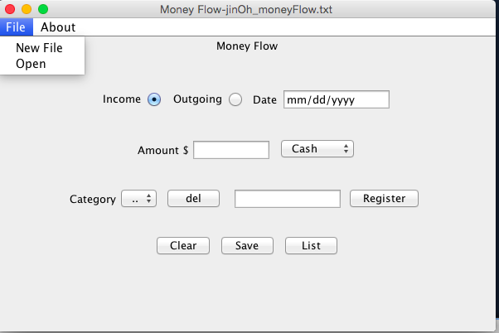

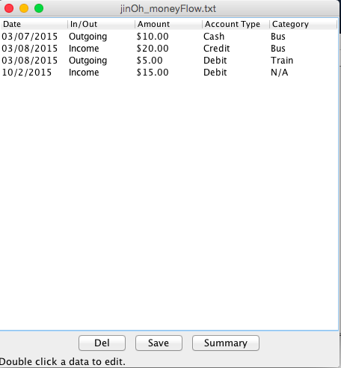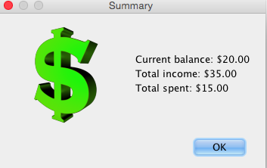

UML Diagram